- How to create EC2 Instance in AWS?
- Select region first.
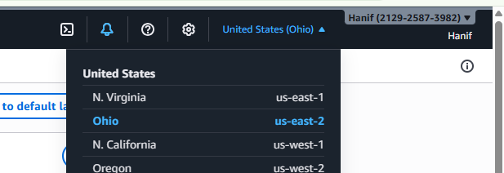
- Search EC2 In search bar
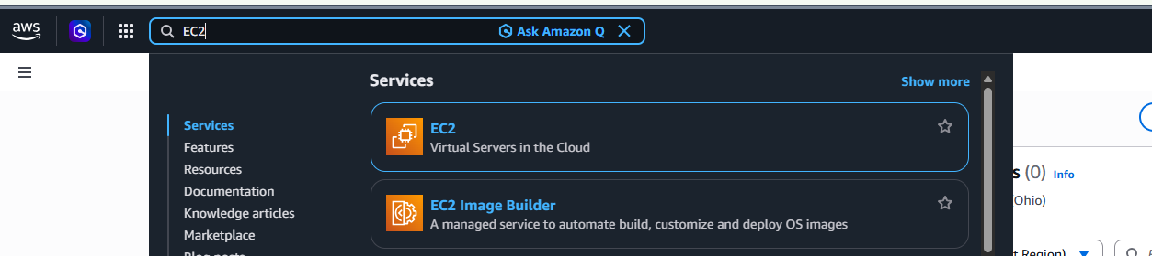
- Select EC2 in operation and click launch Instance button
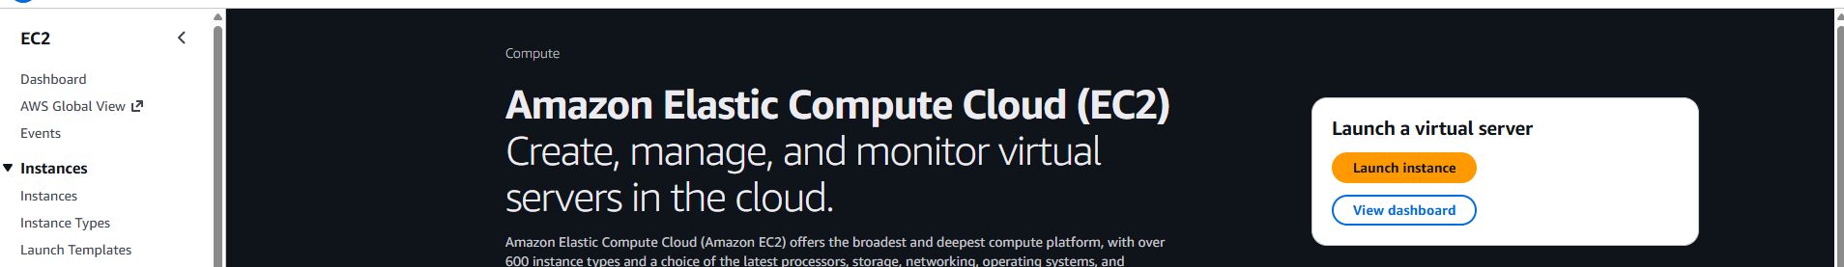
- Provide Name for Instance in Name and tag panel.
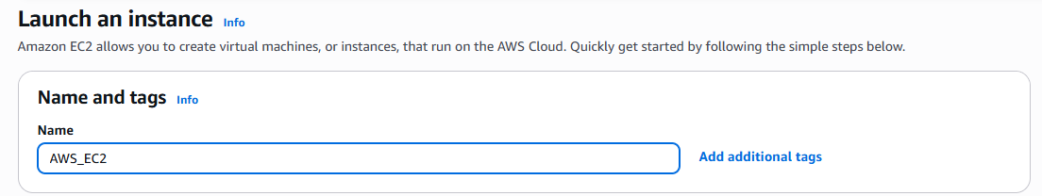
- What is AMI (Amazon Machine Images) Image of our operating system.
- Click browse more AMI button you see below screenshot.
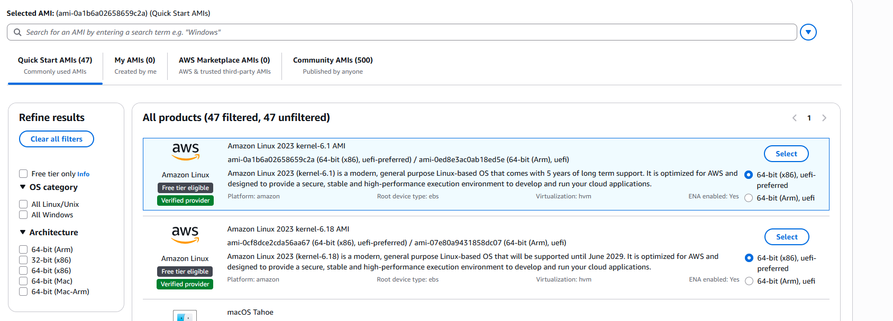
- Select below option for AMI tab
- 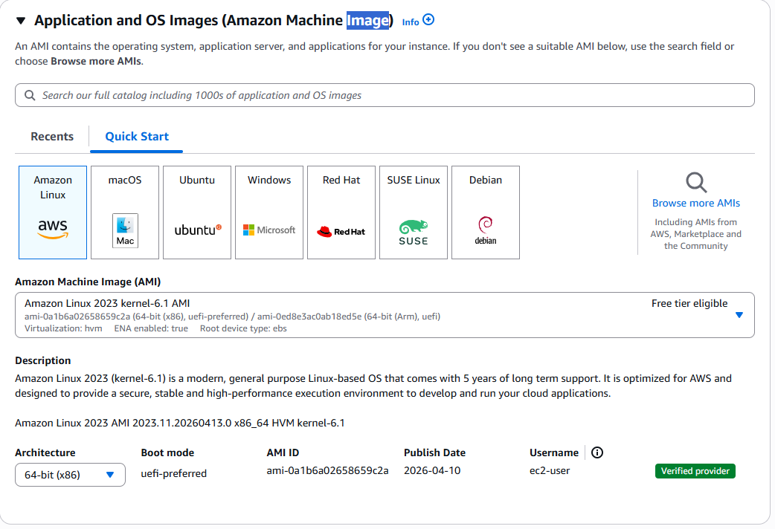
- Select instance type
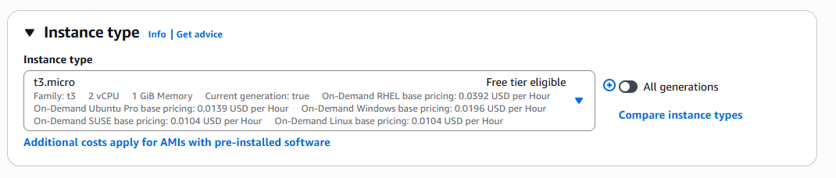
- Type key pair name and this file is now downloaded in your system download function.
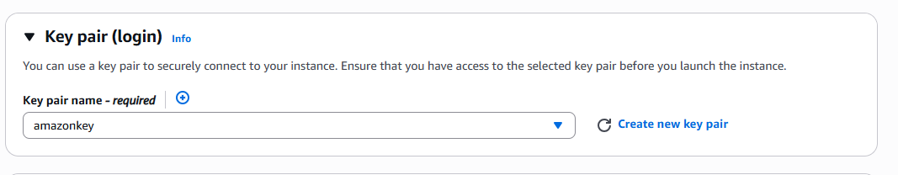
- If you have key of some other instance that key also you can use to your new instance.
- Network tab there is VPC, Subnet and Public IP option also you need to select Firewall (security groups). Create security group name (my-security-group)
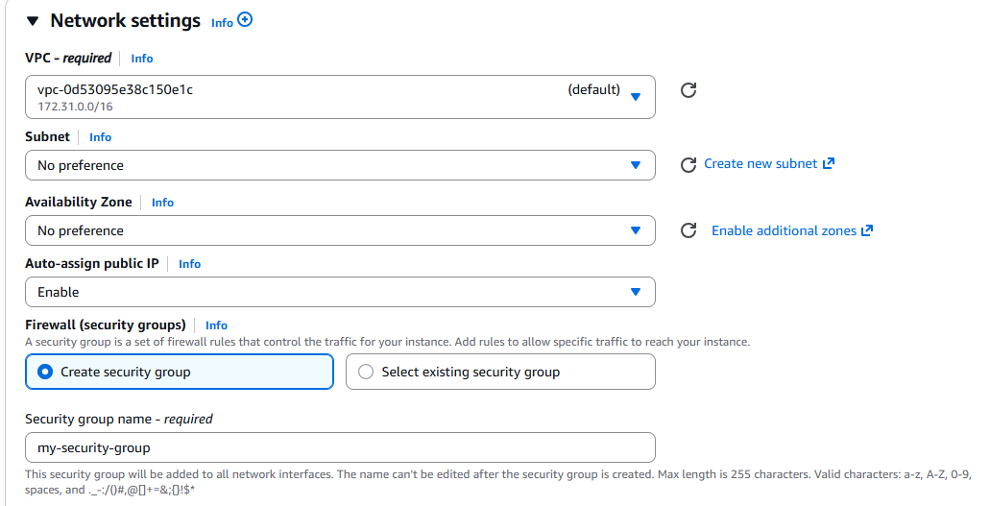

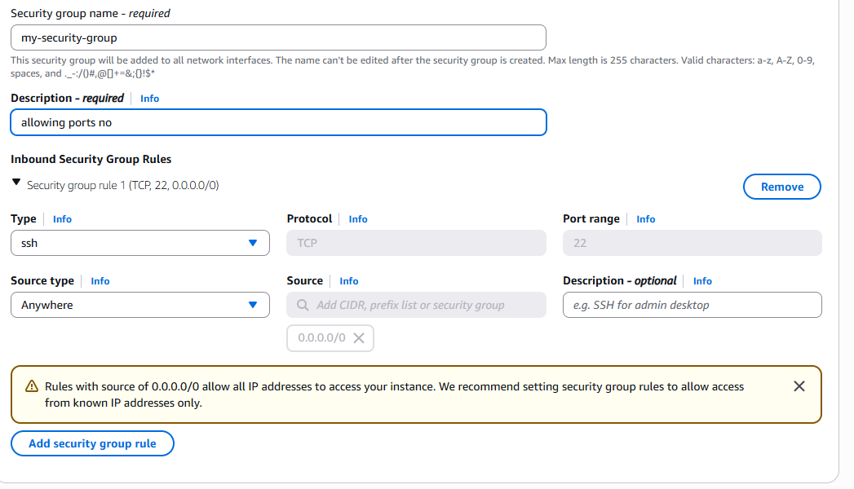
- Now select your configure storage
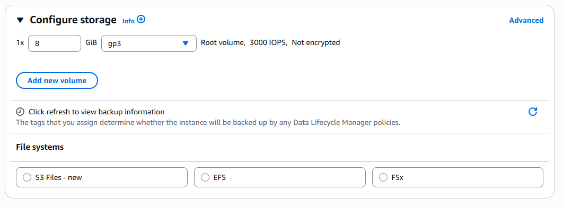
- In advance detail tab
- There is option purchasing options 1) on demand Instances. 2) reserved Instances. 3) spot Instances.
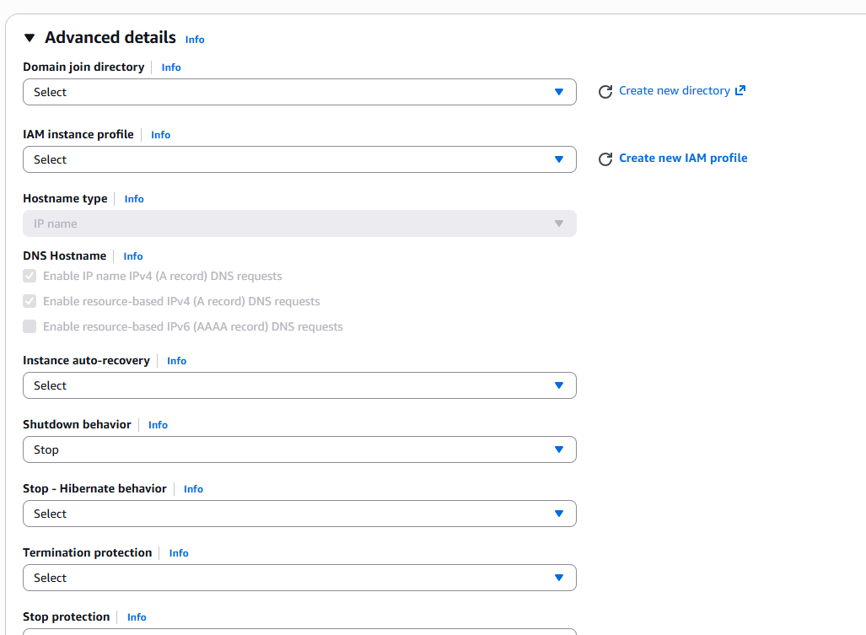
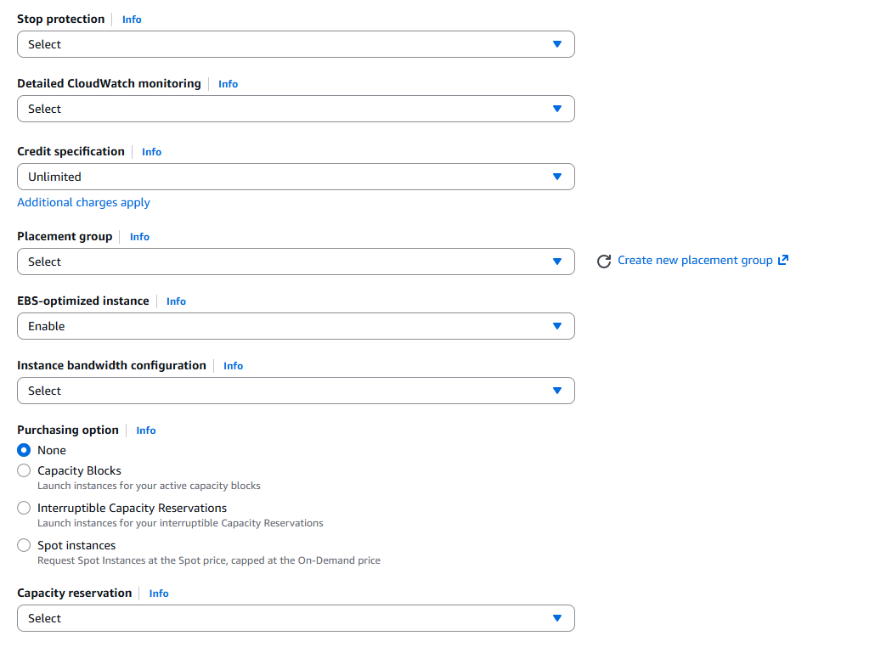
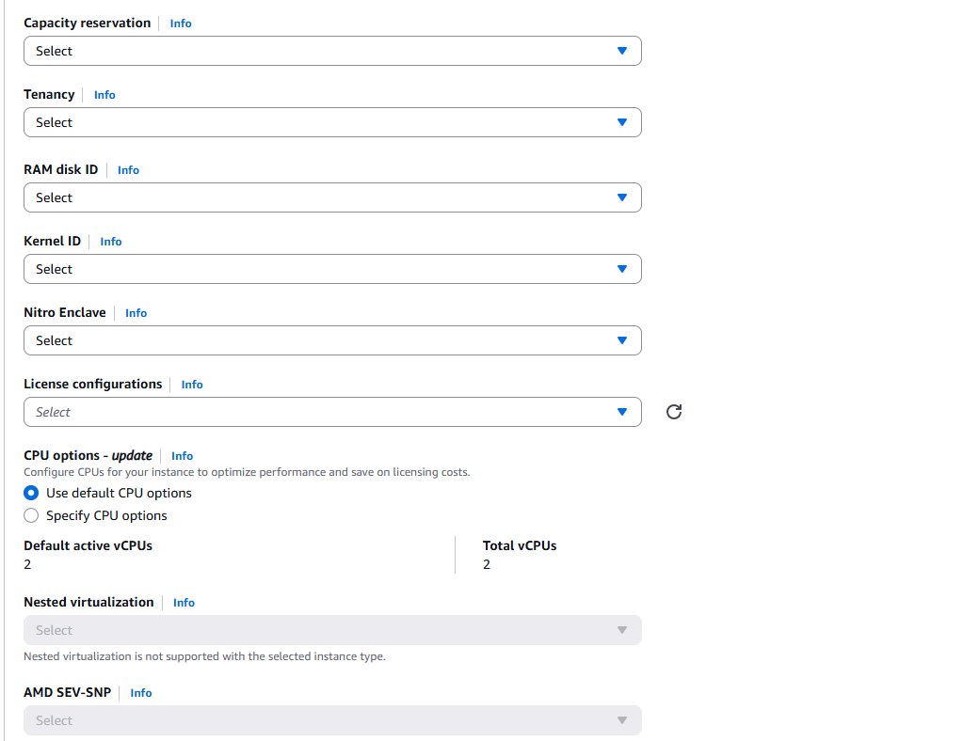
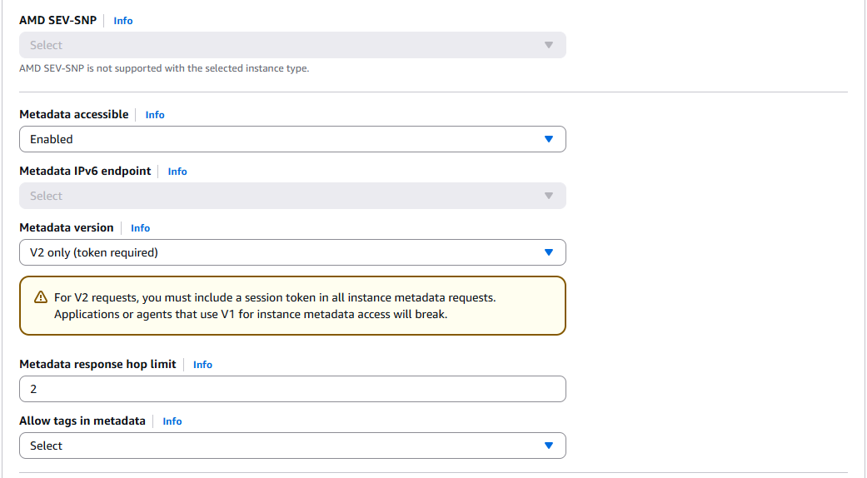
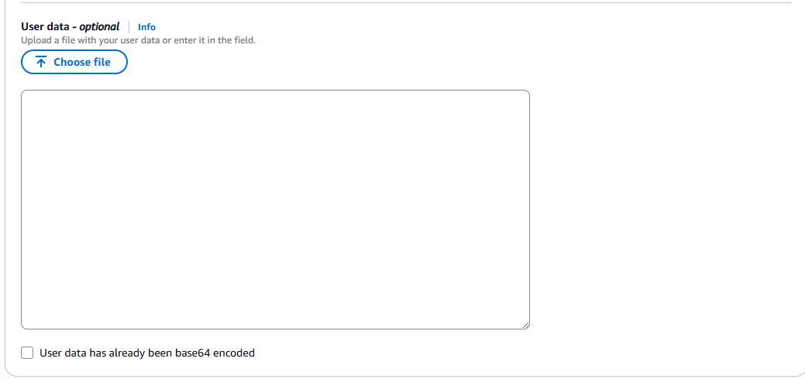
- Now click on launch instance button
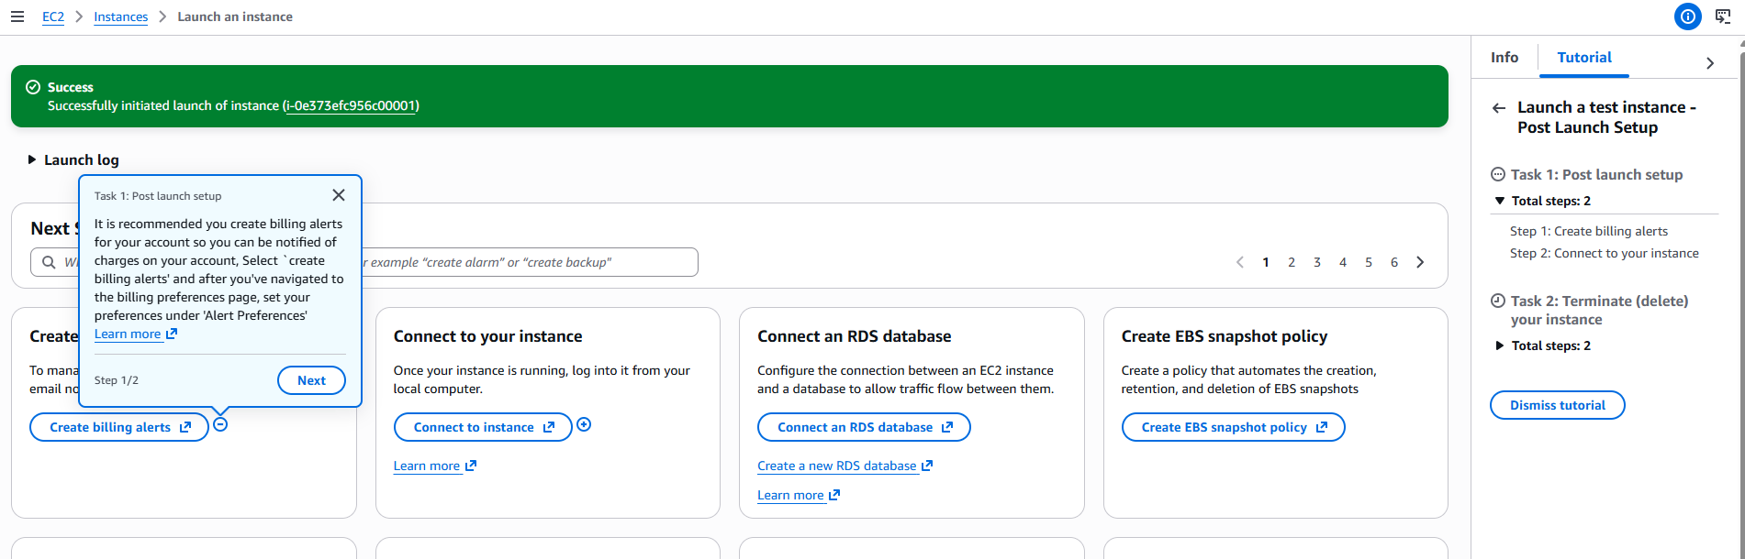
- Now connect your EC2 instance using ssh -I command
- Need to start your httpd service. After that check status.
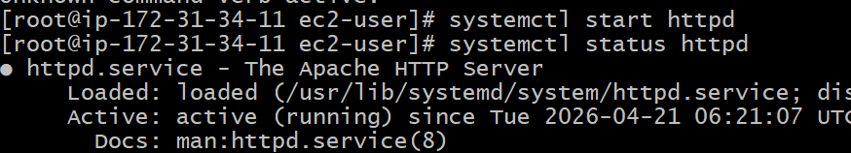
- Check file is created or not when we give command at boot strap time.
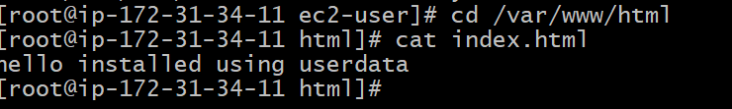
- Now I am running in browser using ip address.
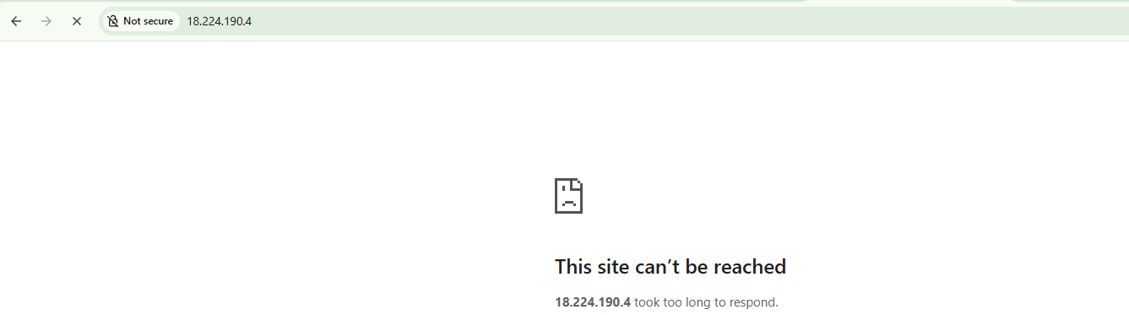
- Because we need add port no in inbound rule
Goto instance—select security option---security groups
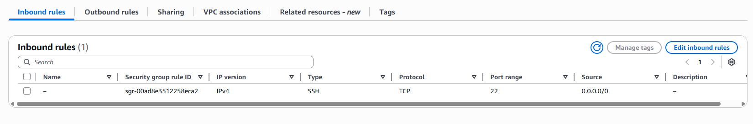
- Now click on Edit inbound rules button
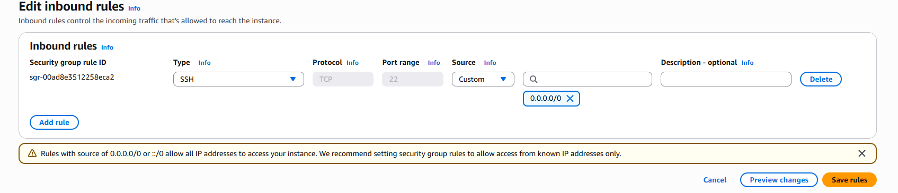
- Add one rule using add rule button
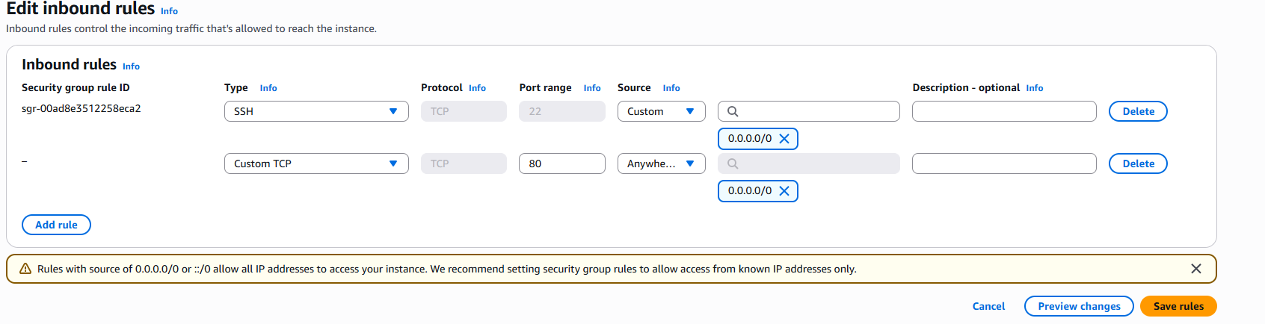
- Now we add custom TCP port 80 source anywhere IPV4 now click on save rules button.
- Now open your browser and refresh your page. You se form is open
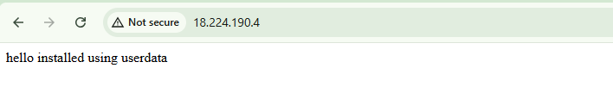
- How to change you Instance Type
- First need to stop your instance
Goto Instance State --- stop instance
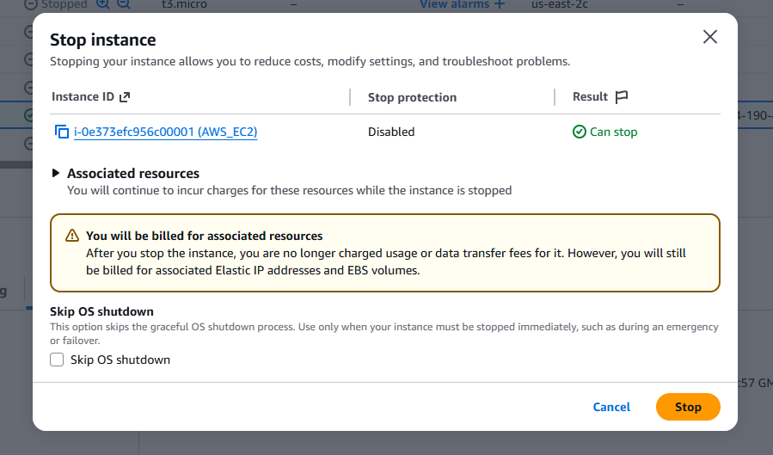
Click on stop button
- To change instance got Action—Instance Setting—change instance type
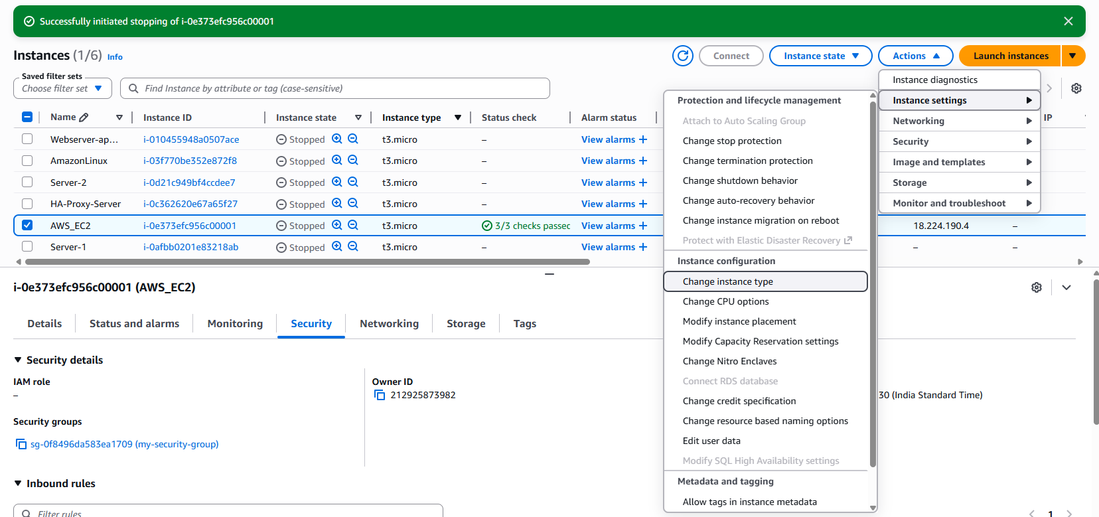
- Now select new instance type
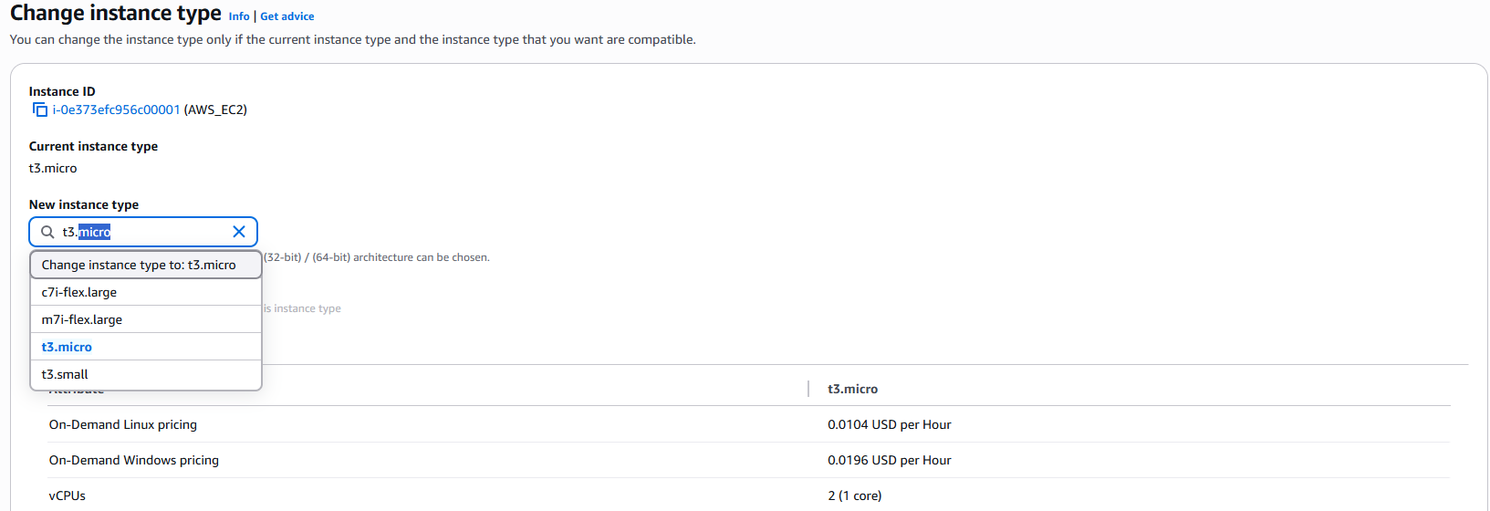
Now click on Change instance type button below in screen. And now you can start your instance.
- Suppose we add team member Taha and I want to provide access to him.
- I will ask him to create a password less authentication using ssh-keygen command. In his local machine By default path is to create file is /c/Users/Admin/.ssh/id_ed25519
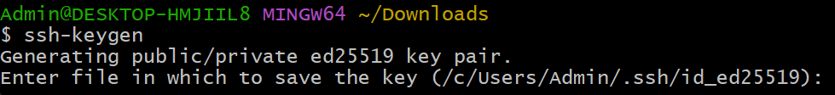
- Using cat /c/users/admin/.ssh/id_ed25519.pub
- Now copy the public key and connect to EC2 instance. Now open authorized_keys file using below command
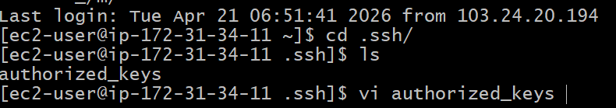
And paste your key and save file. Now exit to your instance using exit commad
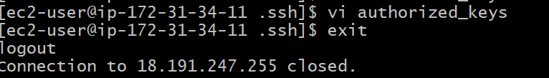
- Now Taha can log in his system using ssh ec2-user@ip Address.
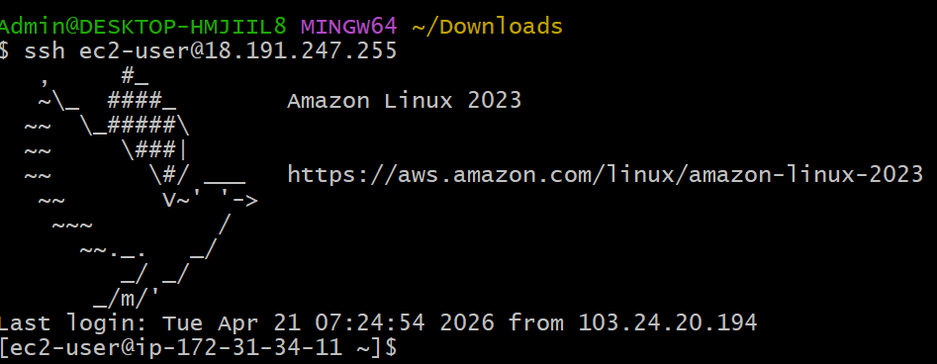
- How to protect your instance from Taha. Now Taha can access instance and delete any file.
- Now I can add one user called Taha.
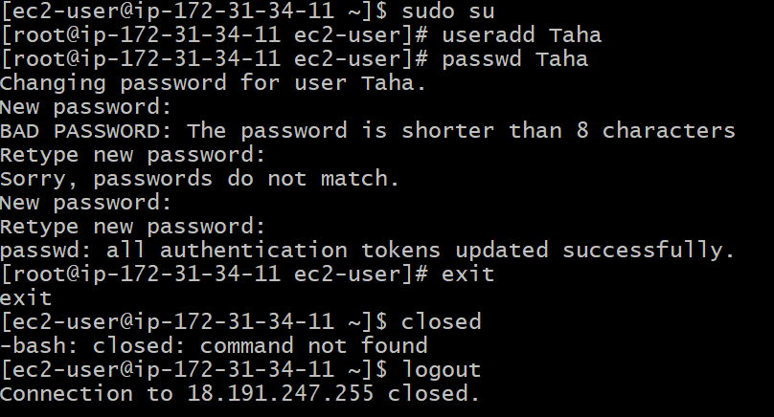
User Taha & password Devops@0509 or Deops@0509
- Now we require any user can login to your EC2 instance not only ec2-user.
- We need to enable PasswordAuthentication yes in /etc/ssh/sshd_config file.
- First go to your EC2 instance suing ssh -I command
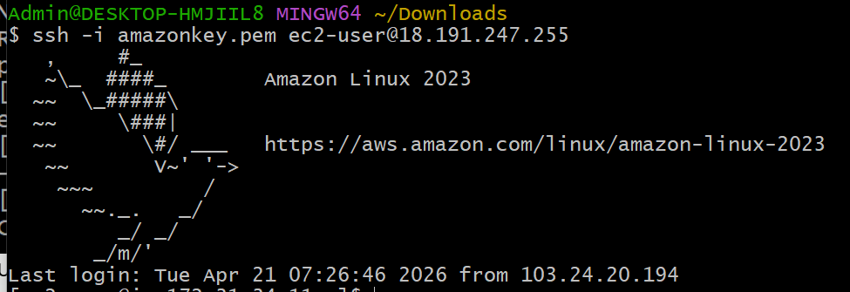
- Now find sshd_config file.
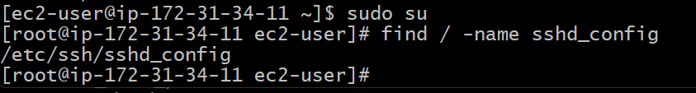
- Now open file using vi command and replace no to yes. And save the file and restart the service
- Using systemctl restart sshd command.
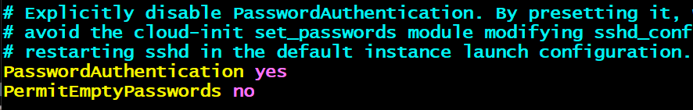
- Now exit from your ec@ instance.
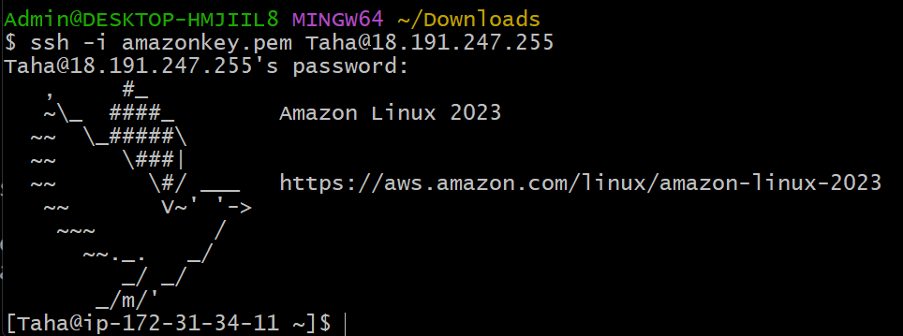
- Now your Taha user connect to EC@ instance. Now Taha user don’t have sudo access so now my server is secure.
- Can I recover my .pem key?
- If loss your pem key or you don’t have password less authentication then you not able to recover your pem key.
- Login to your AWS account- select instance-click on Action button –Image and template-create image
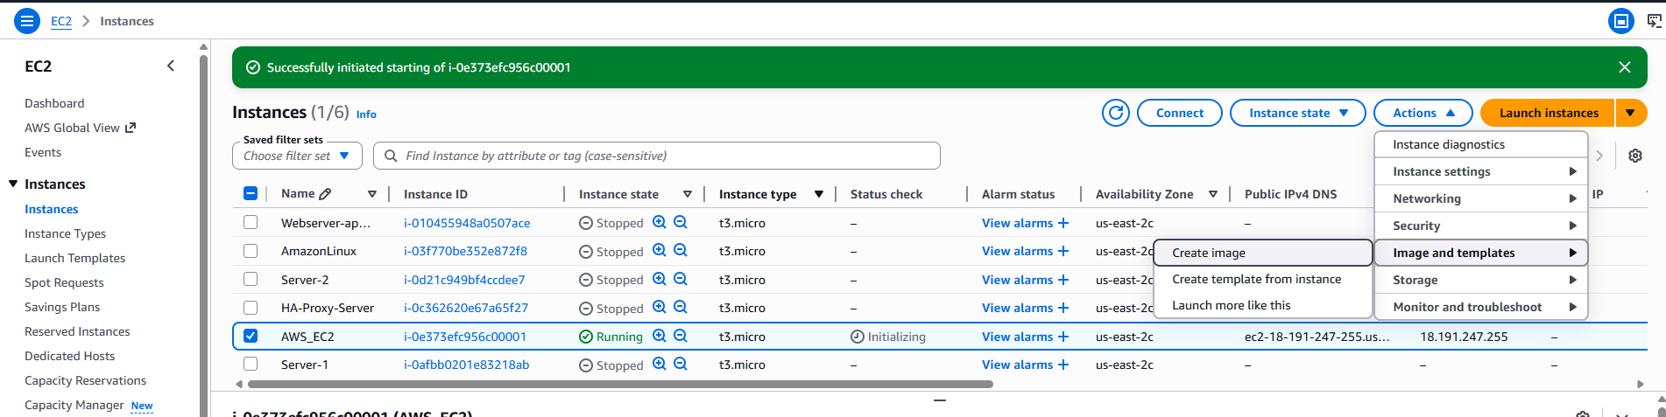
- Enter Image Name & Image description
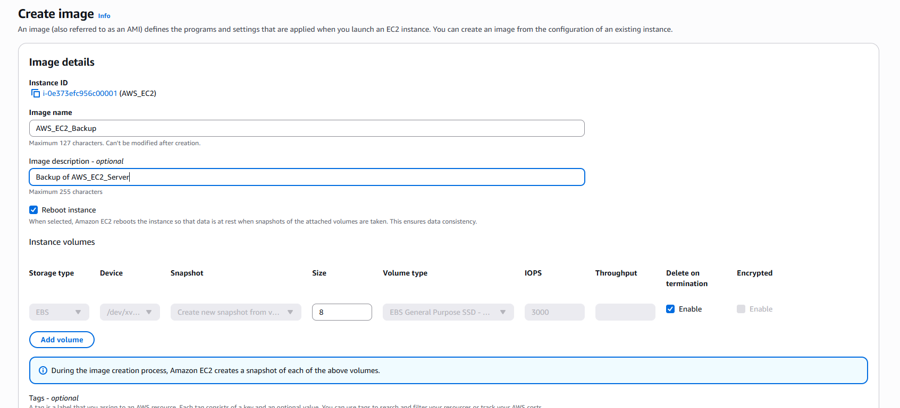
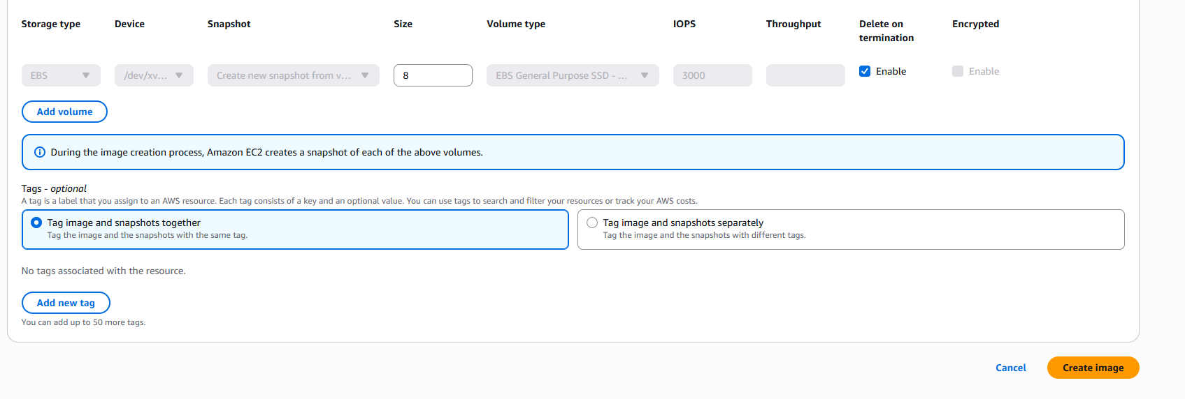
Now click on create image button to create backup of image.
- You can see your backup image in left side menu Images—AMIs option
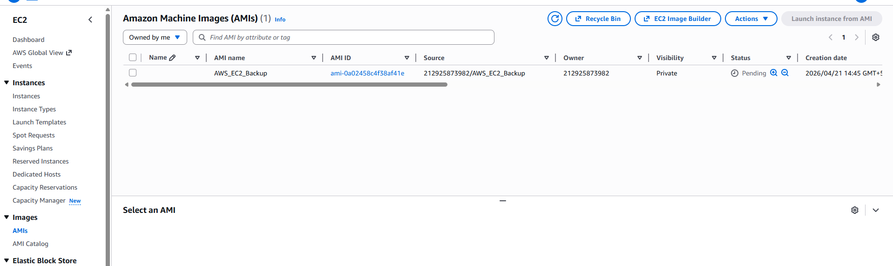
- This process is called snapshot or backup of server.

